| **Test Name** | Manually start pump when pump is not running [Custom Timer] |
| --- | --- |
| **Use Case Tested:** | Manually turn the pump on with custom timer |
| **Test Description:** | This test verifies that the pump can be turned on using the manual on/off switch, and the custom timer value is sent |
| **Pre-conditions** | * Pump Not Running; * System State of Pump: Not running; * ThingsBoard has not asked the pump to start running via manual operation. * Automation: Off. * Est. Timer: Off. * Custom Timer: On. |
| **Post-conditions** | * Running LED: On * Manual Switch: On * Transmit Status: Successful * Pump On with Est. Custom value |
| **Notes:** |  |

|  | **TEST STEP** | **EXPECTED TEST RESULTS** |
| --- | --- | --- |
|  | Use the Dash to send a manual pump on message. | * Switch changes from off to on. * Transmit status becomes “In-Transit”. * Event Log shows Manual On message. * A downlink command is scheduled with payload 0x03 xx yy where xx yy are the hex values of the custom timer shown on the dashboard. |
|  | Send a status message from pump controller. | * Pump controller sends a status message with pumpRunning: 0. * Dash still displays “In-Transit”. |
|  |  | * Pump controller receives command and switches pump on with a message giving the timer information. * Pump controller sends a status message with pumpRunning: 1. * Dash displays transmit status success. |

|  |  |  |  |  |  |
| --- | --- | --- | --- | --- | --- |
| **Test Data Table** | | | | | |
|  | **1** | **2** | **3** | **4** | **5** |
| Custom Timer | 15 |  |  |  |  |

**Results**

05/09/2020

**SUCCESS!**

Manual On sent. Received with correct timer value. Dash updated.

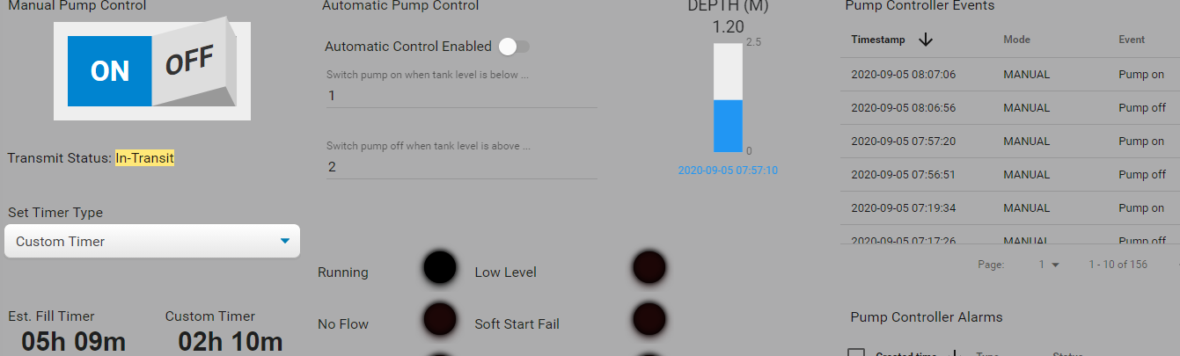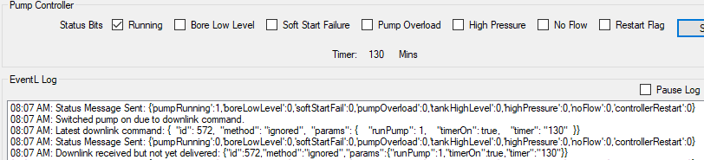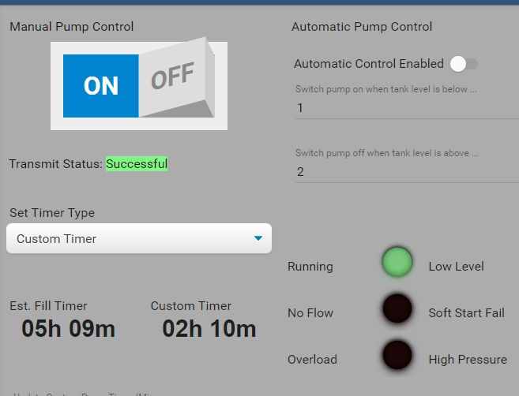

9/9/2020 – On site test at OAI.

Success.

Step 1.

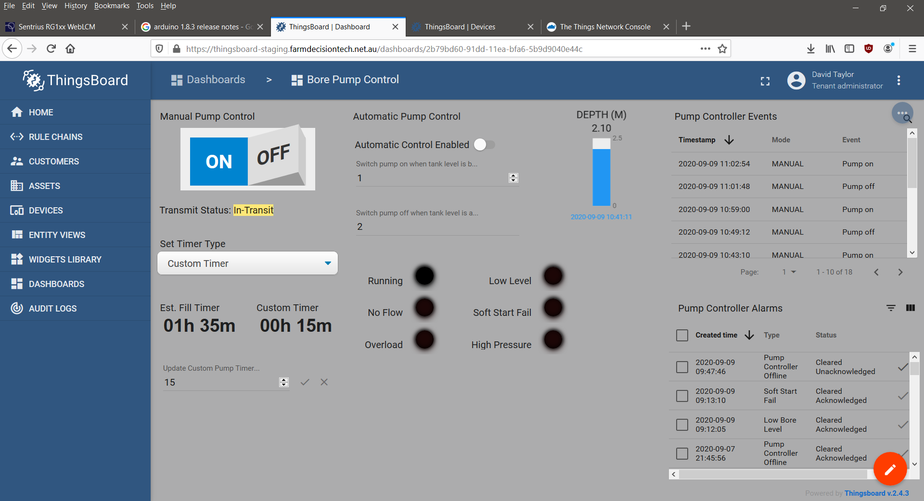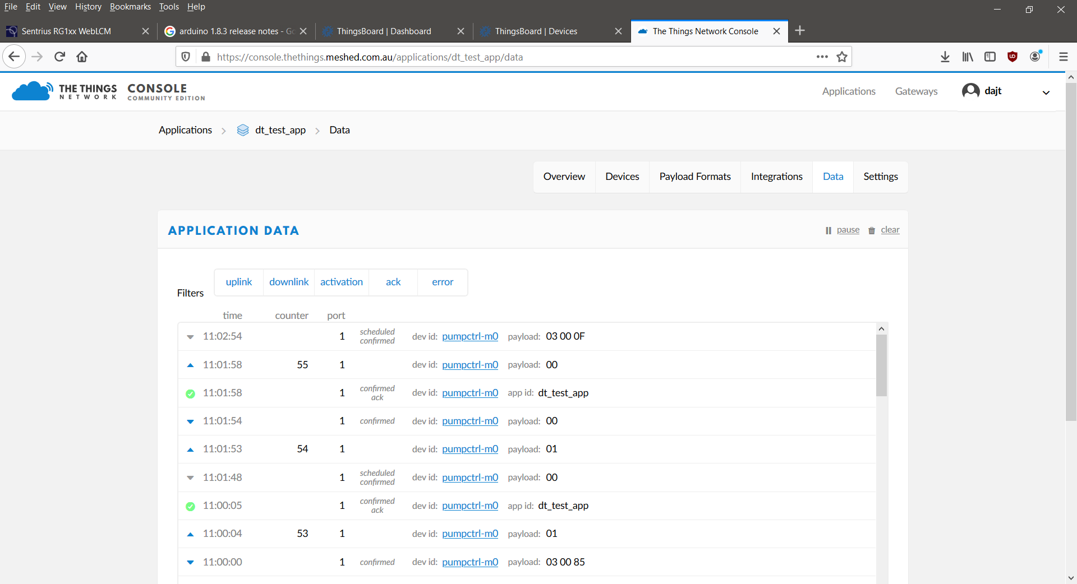

Steps 2 & 3.

11:03:47.598 -> Send operator requested status message.

11:03:47.598 -> LoRaWAN will encode and send this message: {'pumpRunning':0,'boreLowLevel':0,'softStartFail':0,'pumpOverload':0,'controllerRestart':0,'highPressure':0,'noFlow':0}

11:03:47.598 -> Sending status byte: 00

11:03:48.671 -> EV_TXCOMPLETE (includes waiting for RX windows)

11:03:48.671 -> Received reply with 3 bytes:

11:03:48.671 -> 03 00 0F

11:03:48.671 -> callback got data 3

11:03:48.671 -> Switched pump on.

11:03:48.671 -> Starting one-shot timer.

11:03:48.671 -> Timer in minutes: 15

11:03:48.719 -> Sending status due to state change.

11:03:48.719 -> LoRaWAN will encode and send this message: {'pumpRunning':1,'boreLowLevel':0,'softStartFail':0,'pumpOverload':0,'controllerRestart':0,'highPressure':0,'noFlow':0}

11:03:48.719 -> Sending status byte: 01

